**Output**

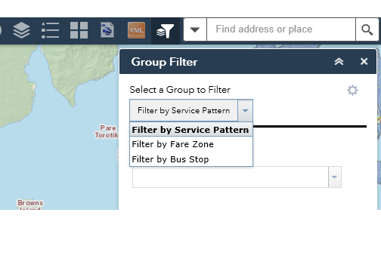

**Configuration**

1. **Set the URL**

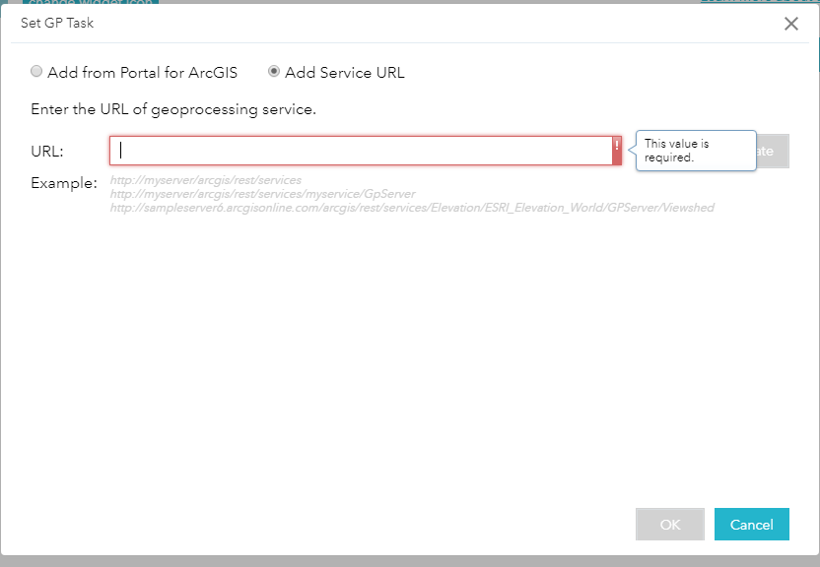

**Eg https://atalgisau01.aucklandtransport.govt.nz/arcgis/rest/services/PT/EODXMLToFeatureclass/GPServer/EOD%20XML%20To%20Featureclass%20v4**

1. **Set the parameters**

